**Fall Buzzer**

To make active buzzer beep with a PNP transistor through raspberry pi,

* Connect a buzzer with a positive pin connected to 3.3V and negative pin connected to the emitter of the transistor while the base is connected to GPIO17 through a 1K resistor and collector is connected to the ground of GPIO.

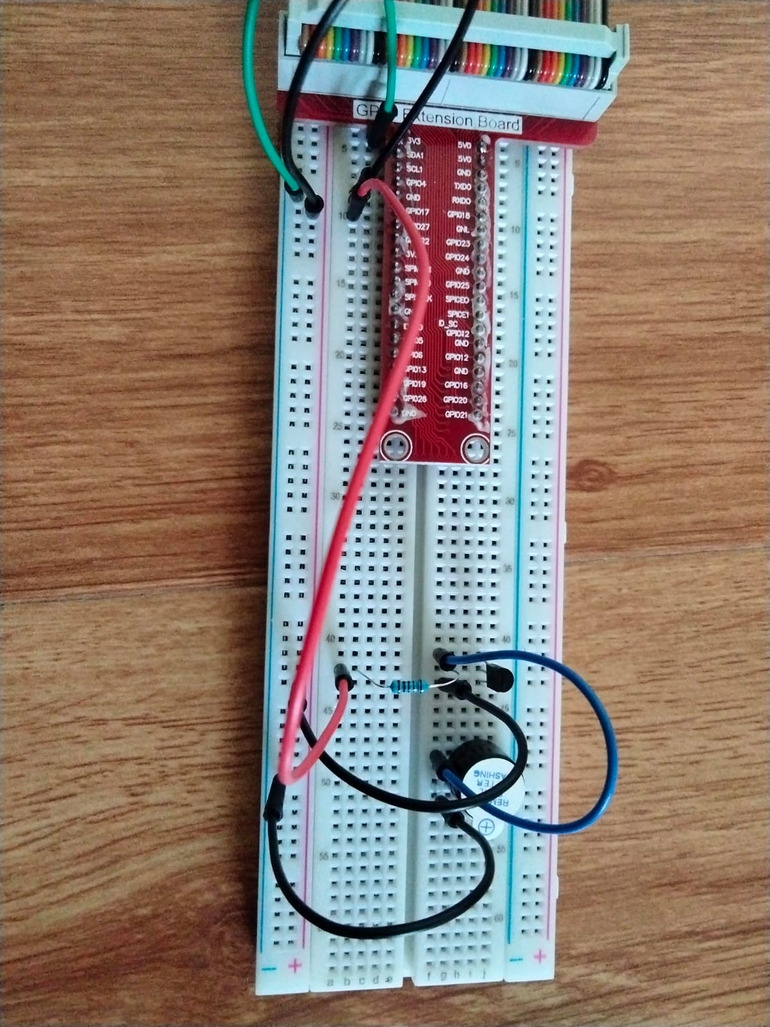

* Now give power supply to Raspberry pi.
* Connect the pi through VNC viewer.



* Now open python and open a new file.



* Write the code to make Buzzer beep and save it with .py extension(Buzzer.py)

**Code:**

**import RPi.GPIO as GPIO # include python lib in RPi**

**import time**

**BeepPin = 11 # pin11**

**def setup():**

**GPIO.setmode(GPIO.BOARD) # Numbers GPIOs by physical location**

**GPIO.setup(BeepPin, GPIO.OUT) # Set BeepPin's mode is output**

**GPIO.output(BeepPin, GPIO.HIGH) # Set BeepPin high(+3.3V) to off beep**

**def loop():**

**while True:**

**GPIO.output(BeepPin, GPIO.LOW) # Switch on Buzzer**

**time.sleep(0.1) # 0.1s delay**

**GPIO.output(BeepPin, GPIO.HIGH)**

**time.sleep(0.1)**

**def destroy():**

**GPIO.output(BeepPin, GPIO.HIGH) # beep off**

**GPIO.cleanup() # Release resource**

**print('Press Ctrl+C to end the program...')**

**setup()**

**try:**

**loop()**

**except KeyboardInterrupt: # When 'Ctrl+C' is pressed, the child program destroy() will be executed.**

**destroy()**

* Now to make the Buzzer beep, run the program
* Sudo python Buzzer.py

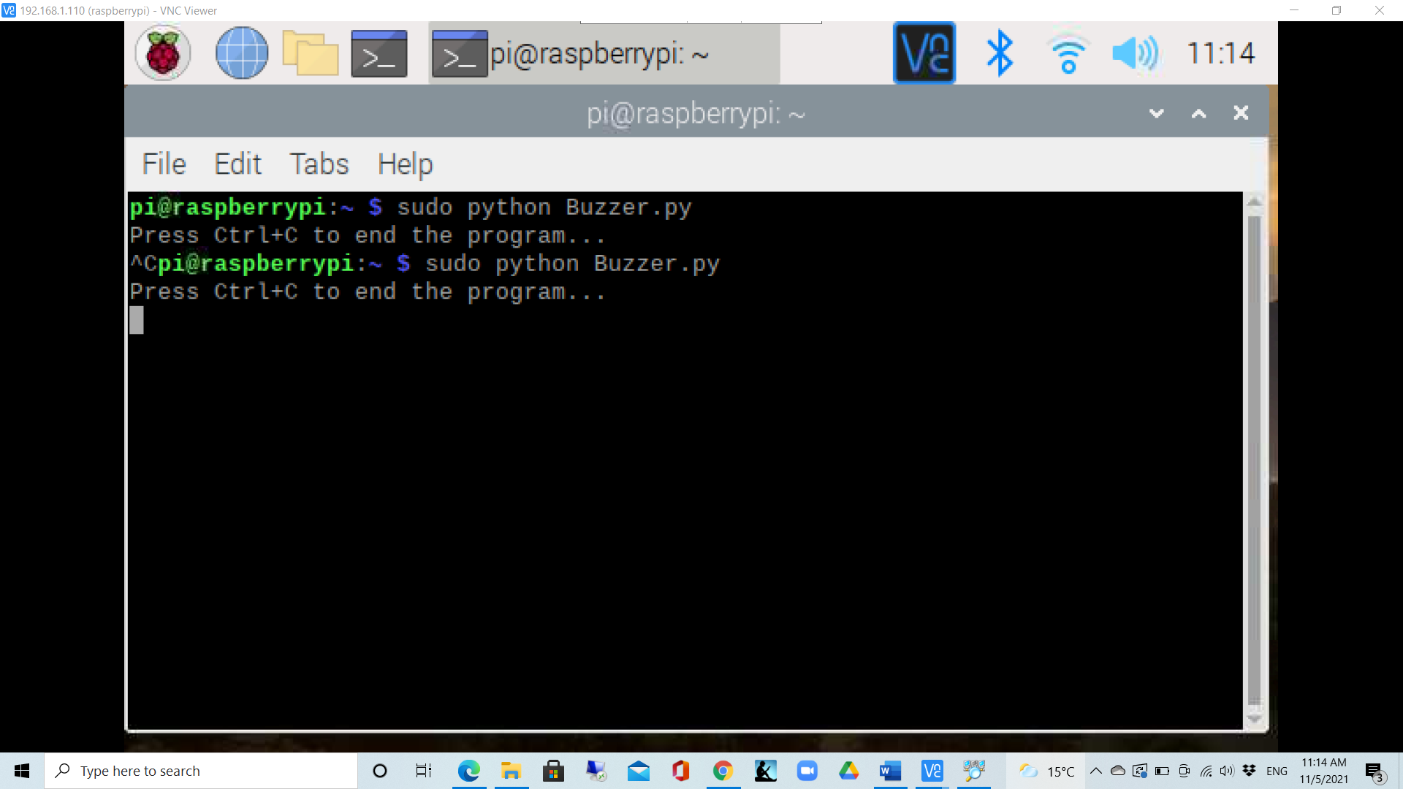

* Now Buzzer beeps.
* To stop the beep of Buzzer, press ctrl+C